### FINAL PROJECT REPORT

ON

# “STUDENT DATABASE MANAGEMENT SYSTEM”

Submitted in partial fulfillment of the requirements for

the award of degree of

**BACHELOR OF ENGINEERING**

**IN**

**COMPUTER SCIENCE & ENGINEERING**



**Submitted to: DR SHRUTI AGGARAWAL,**

**BILAL AHMED MANTOO**

**Submitted By:**

**MD MEHRAN AKHTAR (20BCS7123)**

**VISHAL SINGH (20BCS7138)**

**ABHISHEK PANDEY (20BCS7143)**

**KUSHAL ARORA (20BCS7134)**

**DEPARTMENT OF COMPUTER SCIENCE & ENGINEERING**

**Chandigarh University**

**CERTIFICATE**

This is to certify that the work embodied in this Project Report entitled **“STUDENT DATABASE MANAGEMENT SYSTEM”**, being submitted by “20BCS7123, 20BCS7134,20BCS7138, 20BCS7143” 3th Semester for partial fulfillment of the requirement for the degree of **“ Bachelor of Engineering in Computer Science & Engineering ”discipline in “Chandigarh University”** during the academic session JULY-AUGUST 2021 is a record of bona fide piece of work, carried out by student under my supervision and guidance in the **“ Department of Computer Science & Engineering ”, Chandigarh University.**

**CONTRIBUTION**

**Kushal Arora(20BCS7134)**

**I was in charge of the front end, I created the header of our site...and created an automatic slideshow, for this i have made a class - slide show container and gave all the styling to it Then I added time for...fading out images....and displaying new images I added the transition effects to improve the styling of the website**

**(Alumni section)**

**Here, I added a division for alumni stories for which i created a main division then created 2 more divs in it by using the section and aside function**

**(Transition effect)**

**For transition I have linked aod plugin and in the body section..I have added the command for controlling the timings of the transition effect**

**(Mape live)**

**Here I have inserted a responsive map by using iframe command and give styling to it**

**Apart from it, I used marque command in the footer**

**DECLARATION**

We, student of Bachelor of Engineering in Computer Science & Engineering , 3th Semester , session: JULY-AUGUST 2021, Chandigarh University, hereby declare that the work presented in this Project Report entitled “STUDENT DATABASE MANAGEMENT SYSTEM” is the outcome of our own work, is bona fide and correct to the best of our knowledge and this work has been carried out taking care of Engineering Ethics. The work presented does not infringe any patent work and has not been submitted to any other university or anywhere else for the award of any degree or any professional diploma.

**Students details and Signature**

**MD MEHRAN AKHTAR (20BCS7123)**

**VISHAL SINGH (20BCS7138)**

**ABHISHEK PANDEY (20BCS7143)**

**KUSHAL ARORA (20BCS7134)**

**APPROVED & GUIDED BY:**

To our Project In charge “DR SHRUTI AGGARAWAL AND BILAL AHMED MANTOO”.

**ACKNOWLEDGEMENT**

We would like to express our deep and sincere gratitude to our Project In charge DR SHRUTI AGGARAWAL AND BILAL AHMED MANTOO for giving us the opportunity to do the project and providing valuable guidance throughout this research. Their dynamism, vision and exquisite efforts have deeply inspired us. They taught us the methodology to carry out the research and to present the research work as clearly as possible. It was a great privilege for us to study and work under their guidance.

We owe the completion of my project to our project Mentor for her continuous support and guidance.

# 

# INTRODUCTION

This project is about the Database Management system that is basically a Web development and DBMS project developed by the students named Md Mehran Akhtar, Vishal Singh , Abhishek Pandey and Kushal Arora. In this project various technologies of Frontend and Backend are used along with the concepts of DBMS.

##### BENEFITS OF STUDENT DATABASE MANAGEMENT SYSTEM

# Easy to use and easy to maintain.

# Affordable and reliable website for various school and colleges to maintain their school records.

# Easy to register various data and displaying data on any browser.

# Proper management of data on server.

# Gives exact date and time of the registration done if any.

# Fast Processing and loading speed but depends on internet speed too.

# Proper authentication Login of the staffs.

**Software and Hardware tools required for Project-**

**Software:**

* XAMPP
* VSCODE
* NOTEPAD
* Some Online Softwares

**Hardware:**

* Processor (CPU) with 2 gigahertz (GHz) frequency or above

A minimum of 2 GB of RAM

* Monitor Resolution 1024 X 768 or higher
* A minimum of 20 GB of available space on the hard disk .Internet Connection Broadband (high-speed) Internet connection with a speed of 4 Mbps.
* Keyboard and a Microsoft Mouse or some other compatible pointing device.

**SCOPE OF PROJECT**

The scope of the project is to deliver this project to the Education institutions like schools and colleges so that they can use this website for the database management system of students and other staffs at a very low cost and in an effective manner. The interface of our Website allows the user to easily use the features of our Website. And is basically just like the day to day life interface and the same is used here.

**TECHNOLOGY TO BE USED**

* HTML

HTML stands for Hyper Text Markup Language. Itis the standard markup language for creating Web pages. It describes the structure of a Web page.It consists of a series of elements. HTML elements tell the browser how to display the content.HTML elements label pieces of content such as "this is a heading", "this is a paragraph", "this is a link", etc.

Hypertext Markup Language (HTML) is the standard markup language for documents designed to be displayed in a web browser. It can be assisted by technologies such as Cascading Style Sheets (CSS) and scripting languages such as JavaScript.

* CSS

CSS stands for Cascading Style Sheets. CSS describes how HTML elements are to be displayed on screen, paper, or in other media. CSS saves a lot of work. It can control the layout of multiple web pages all at once. External stylesheets are stored in CSS files

* JAVASCRIPT

JavaScript often abbreviated as JS, is a programming language that conforms to the ECMAScript specification.JavaScript is high-level, often just-in-time compiled, and multi- paradigm. It has curly-bracket syntax, dynamic typing, prototype-based object-orientation, and first-class functions.

Alongside HTML and CSS, JavaScript is one of the core technologies of the World Wide Web.JavaScript enables interactive web pages and is an essential part of web applications.

The vast majority of websites use it for client-side page behavior, and all major web browsers have a dedicated JavaScript engine to execute it.

* PHP

PHP is a general-purpose scripting language that is especially suited to web development. It was originally created by Danish-Canadian programmer Rasmus Lerdorf in 1994; the PHP reference implementation is now produced by The PHP Group. PHP originally stood for Personal Home Page but it now stands for the recursive initialism PHP: Hypertext Preprocessor.

* MY SQL

SQL is a standard language for accessing and manipulating databases. SQL stands for Structured Query Language. SQL lets you access and manipulate databases. SQL became a standard of the American National Standards Institute (ANSI) in 1986, and of the International Organization for Standardization (ISO) in 1987

SQL can execute queries against a database, retrieve data, insert records in a database, update records ,delete records, create new databases, create new tables in a database, create stored procedures in a database, create views in a database, set permissions on tables, procedures, and views

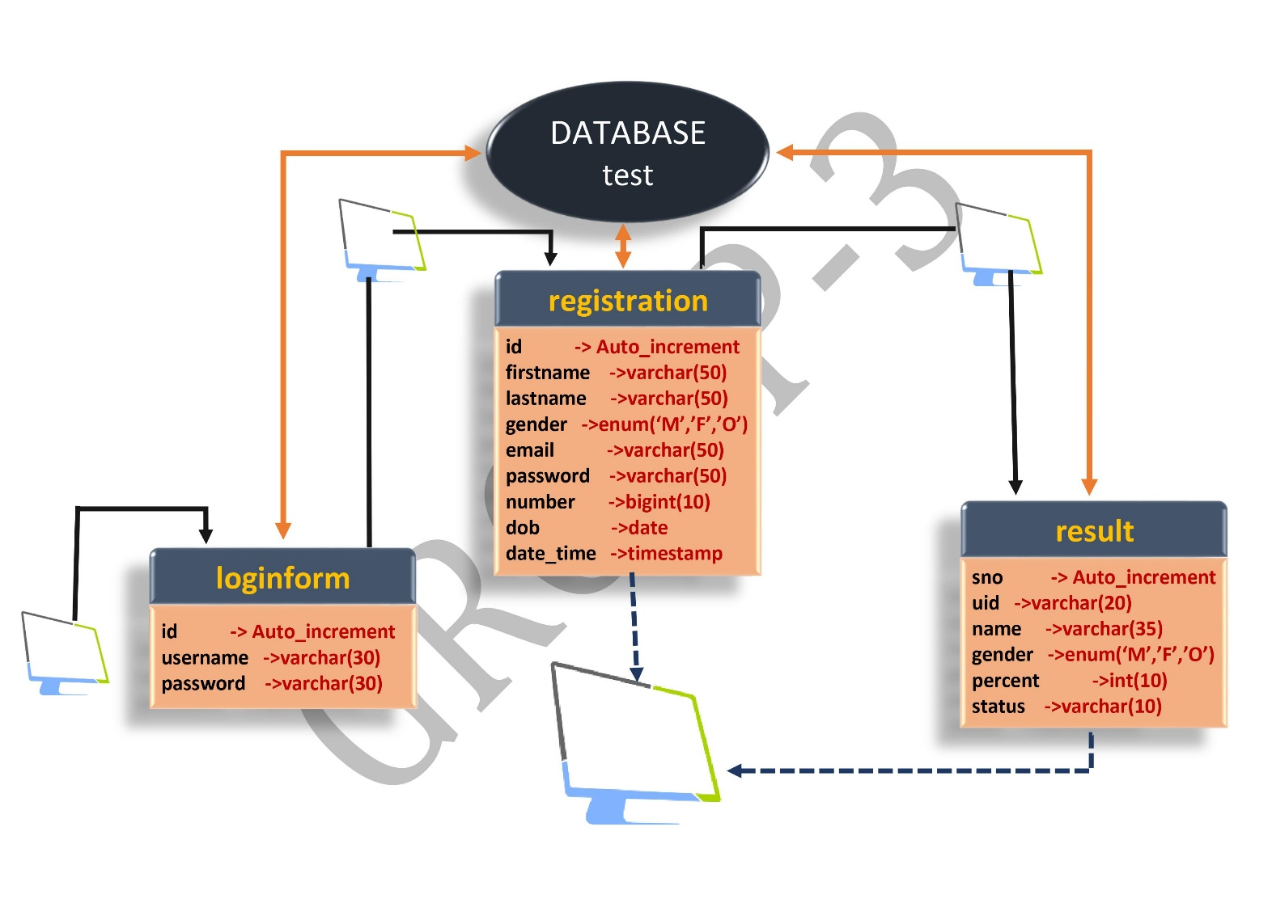**ER DIAGRAM**

**MATEAL AND METHODOLOGY**

**PROJECT DESIGN**

### MODEL APPROACH

INTERFACE REQUIREMENTS

SOFTWARE INTERFACE

* Windows 8/10.
* 4 gb ram / 256gb hdd
* MySQL
* Html
* Javascript & PHP

Several materials are used to built this project . Certain software interfaces are used like window 8/10 , 4gb ram/ 255gb hdd , MySQL . Technologies are also used like Javascript for development of the project. MySQL is used for free open source database to store the data .

TEAM WORK –

**MODULES –** ABHISHEK PANDEY, KUSHAL ARORA

**BACKEND –** MD MEHRAN AKHTAR ,VISHAL SINGH

**CODES**

Due to big lines of codes and huge number of files we have uploaded our whole project code and content on ***GITHUB***. Kindy go through the link to find the codes of our project.

***GITHUB* Link**

<https://github.com/Kushal1907/Student-Database-Management-System>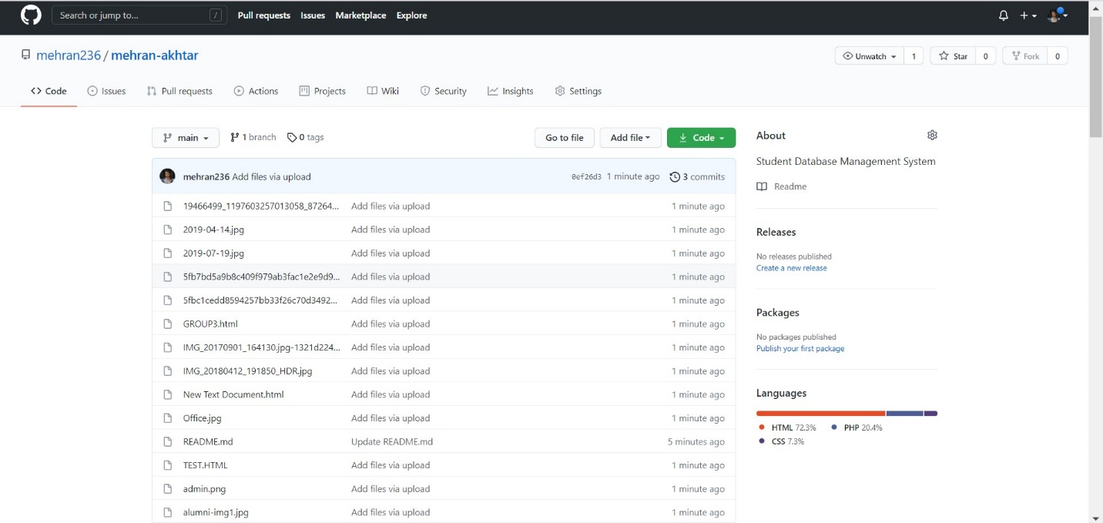

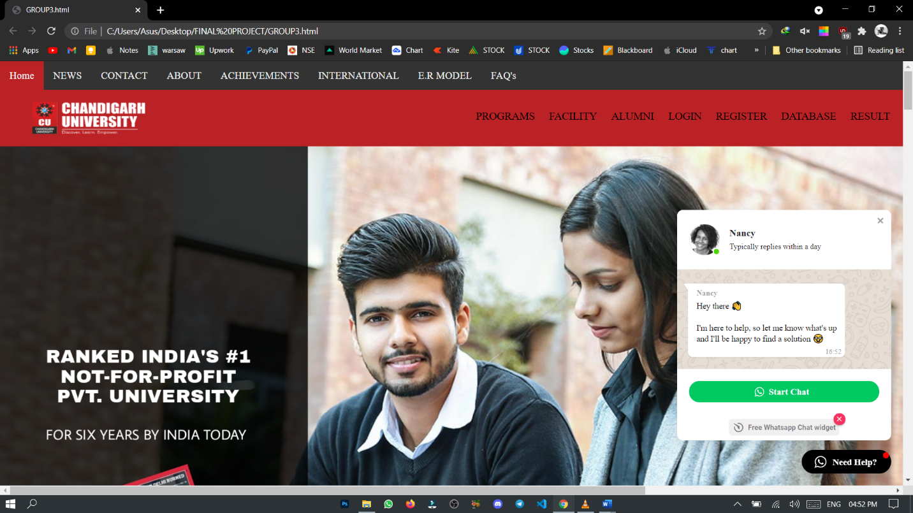

**RESULTS AND SNAPSHOTS**

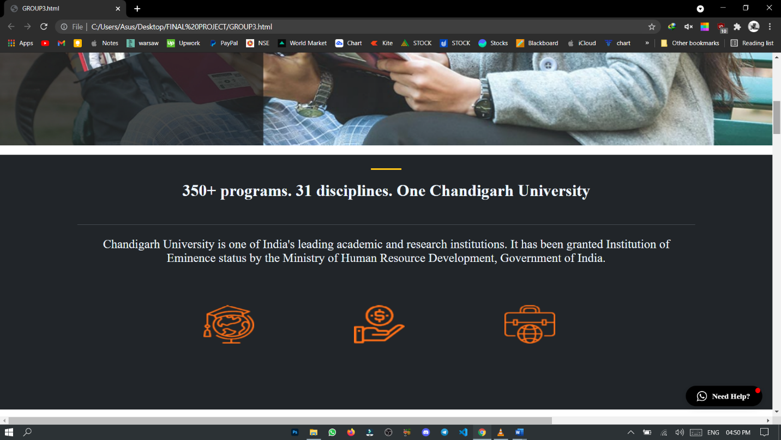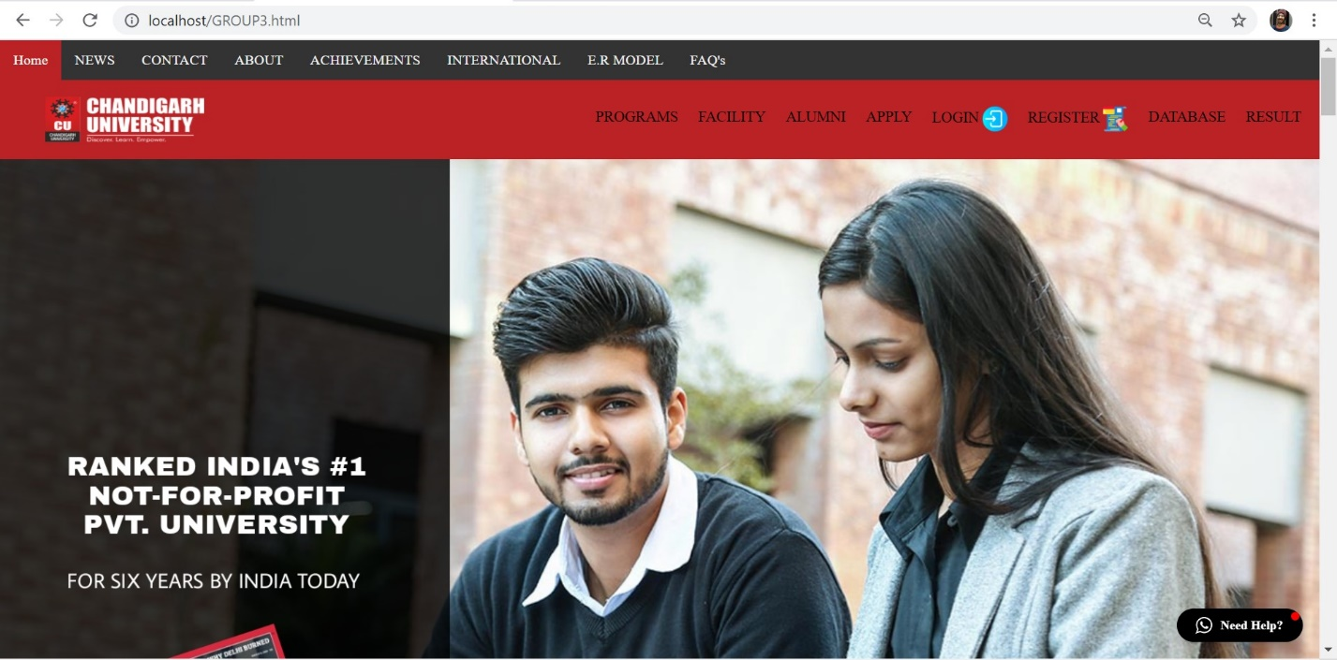

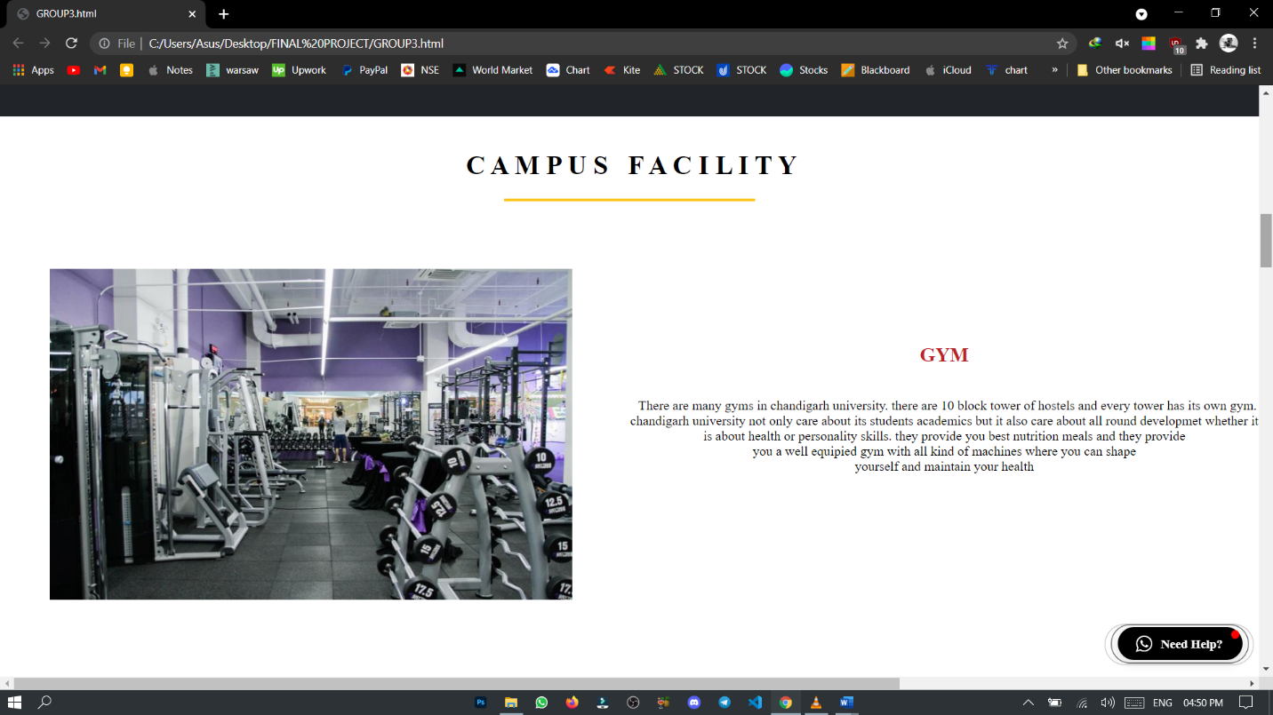

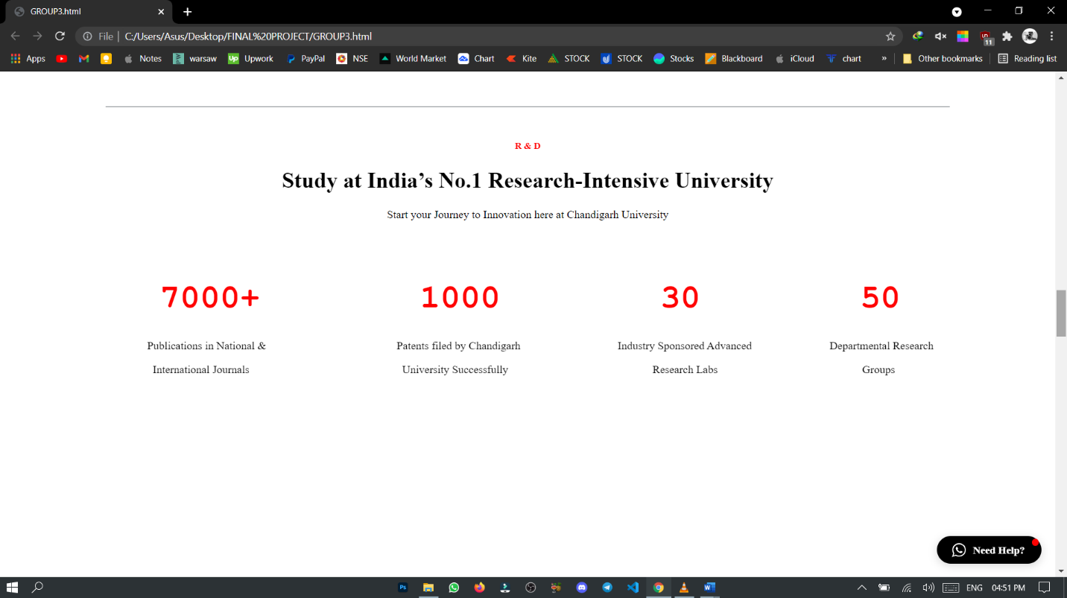

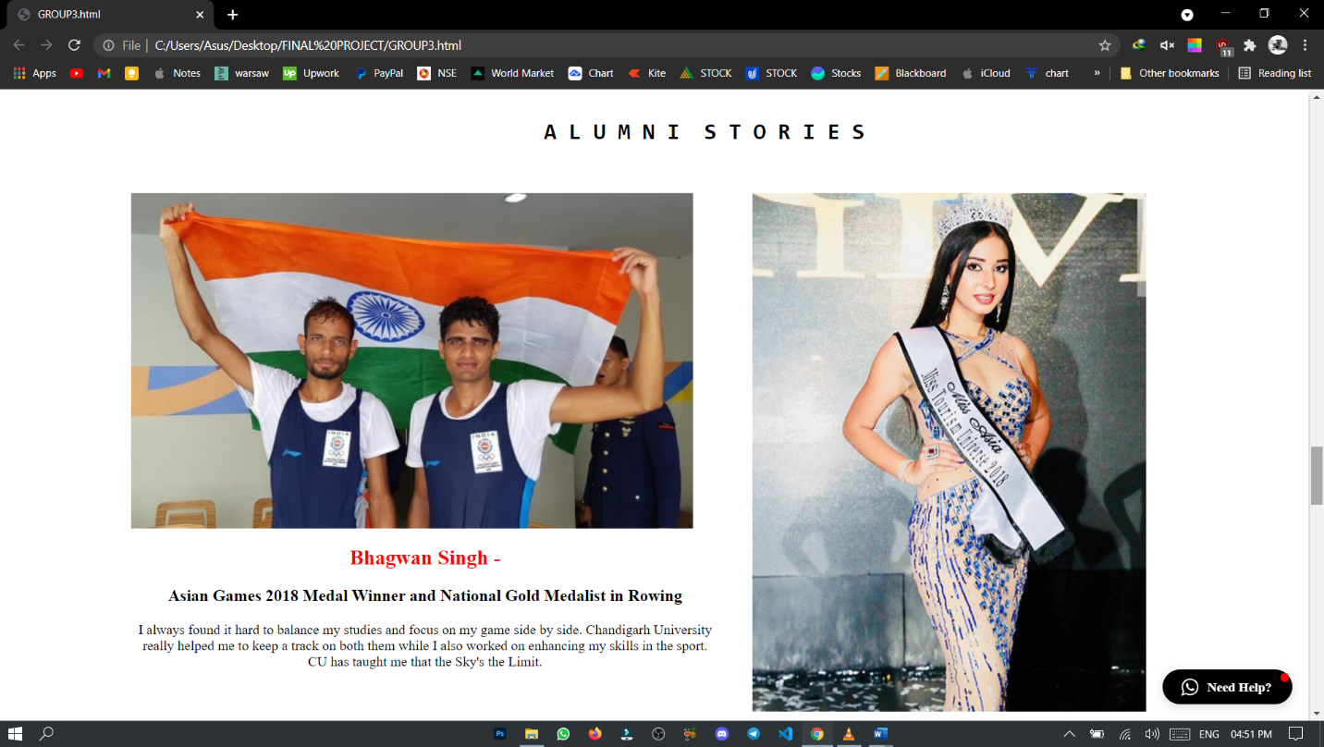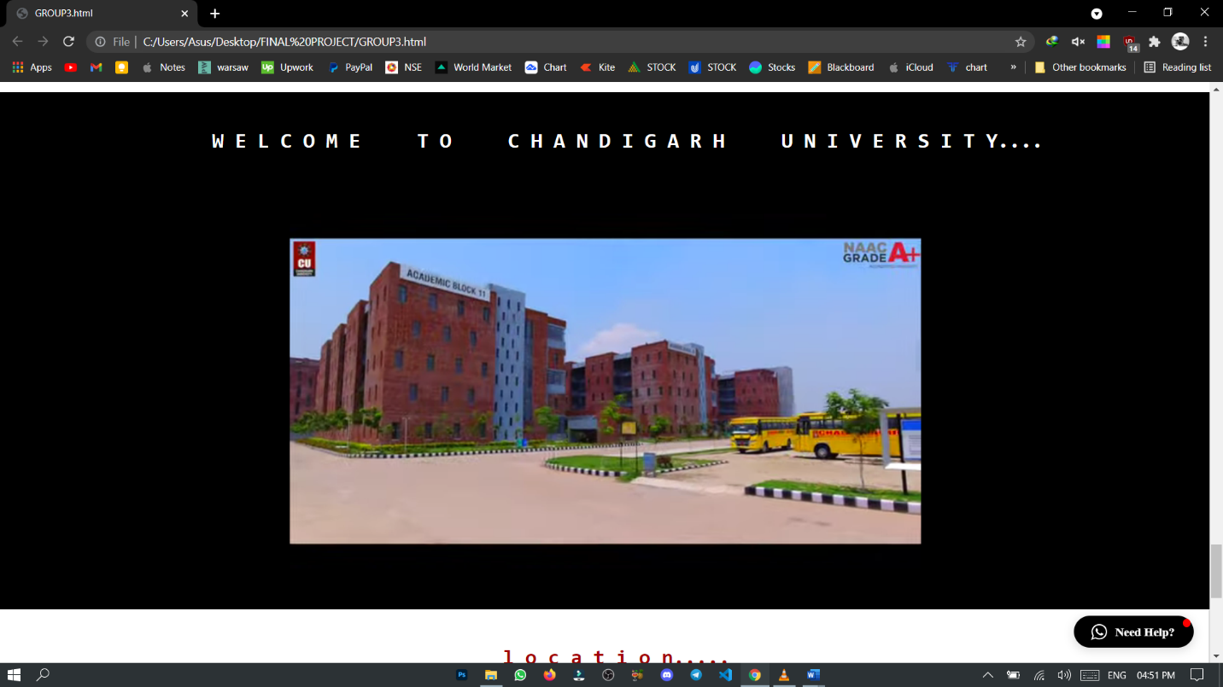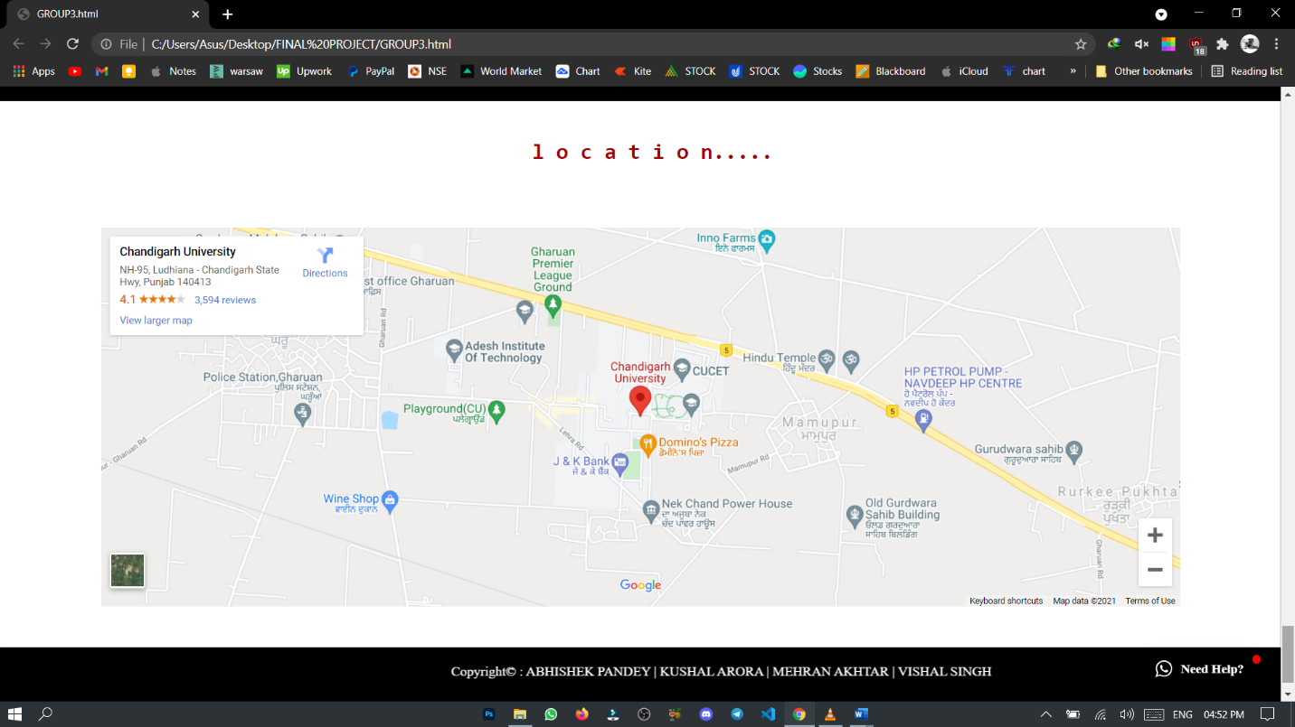

**BACK-END based snapshots**

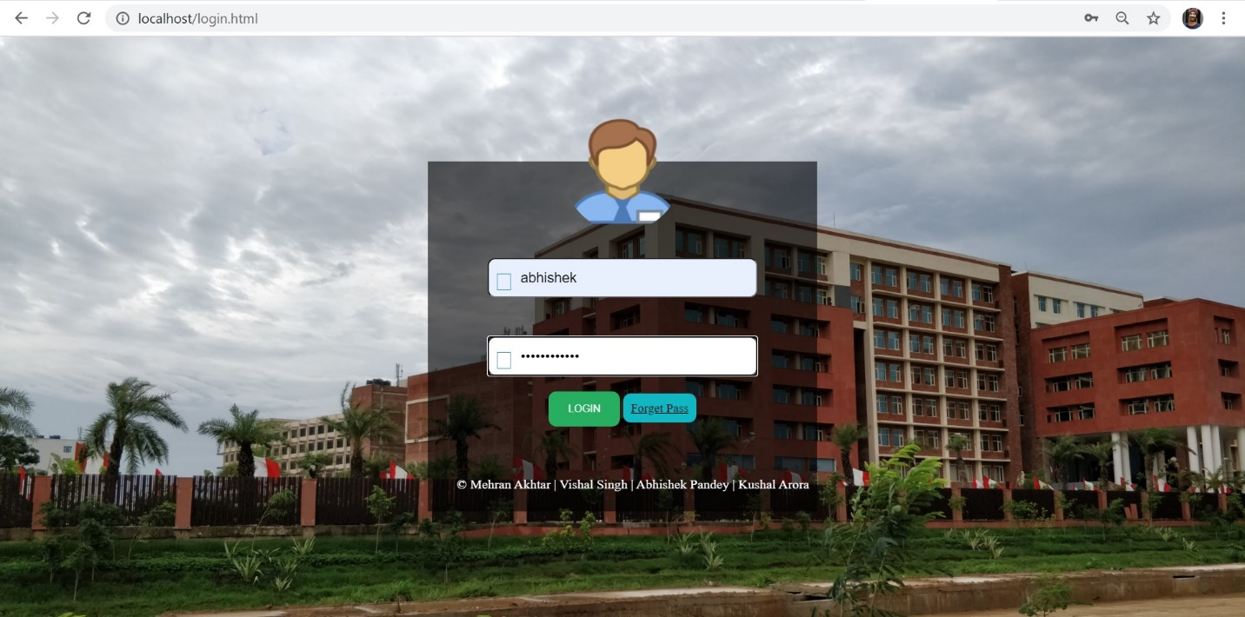1.Login Page

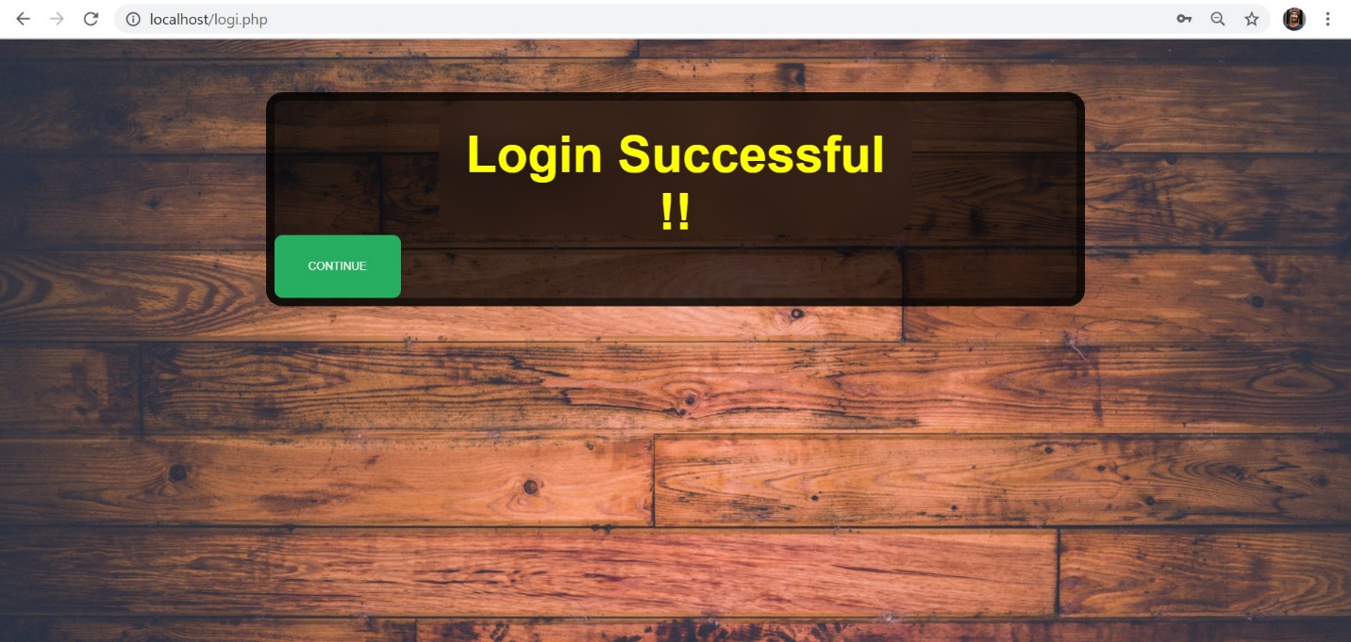2.Login Successful

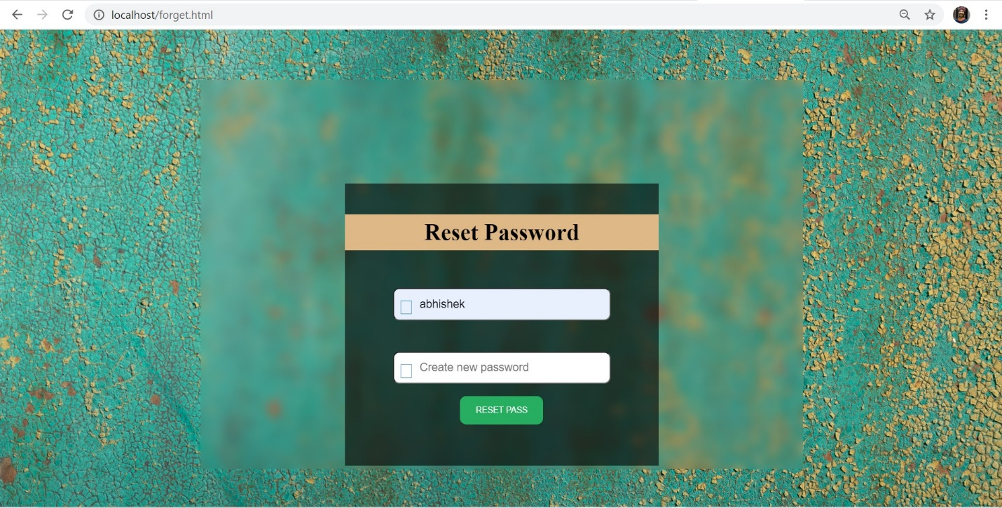3.Reset Password

4.Reset Successful

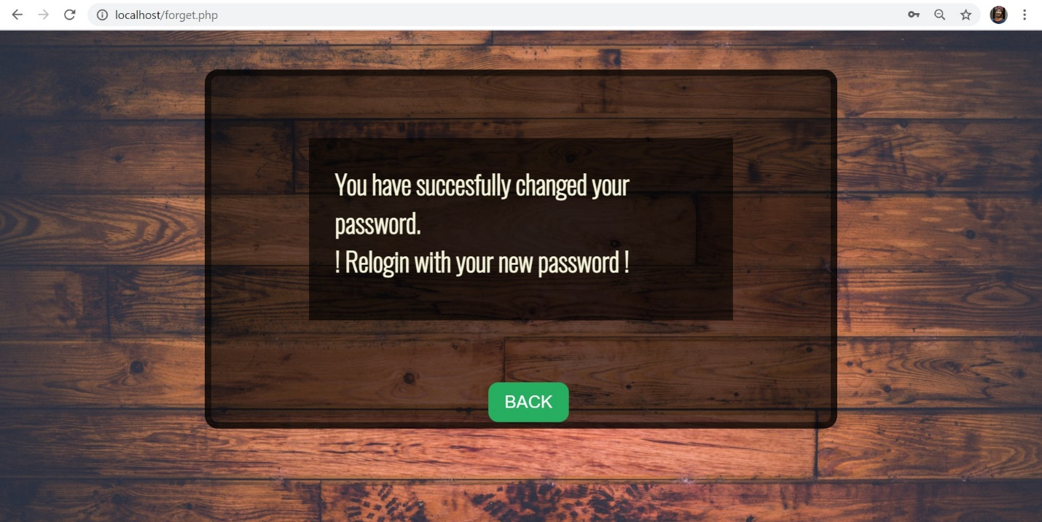

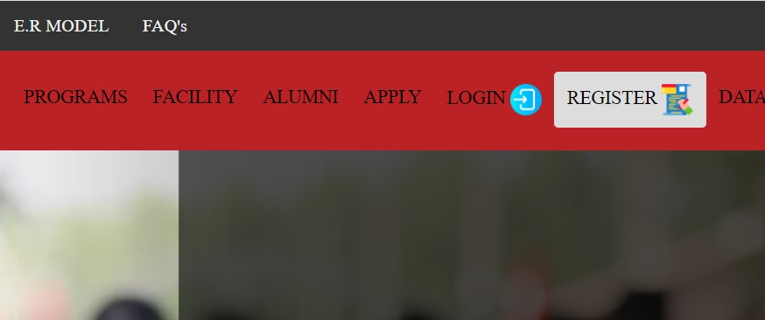

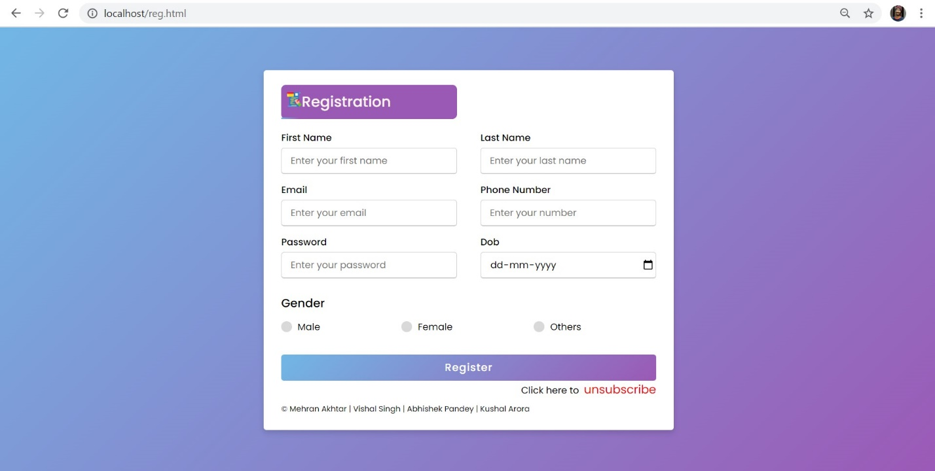5.Registration Form

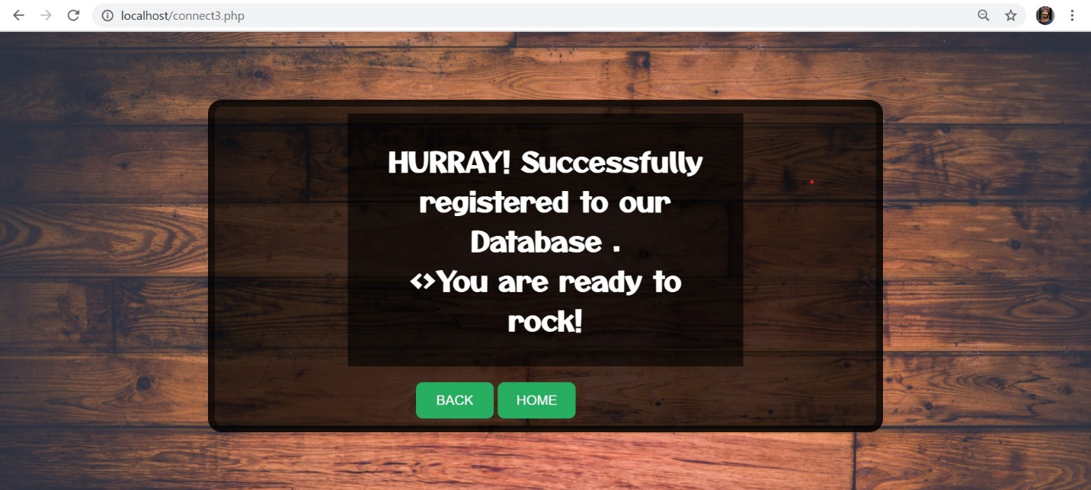6.Registration Successful

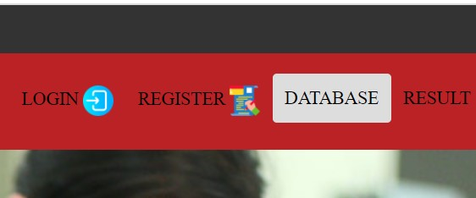

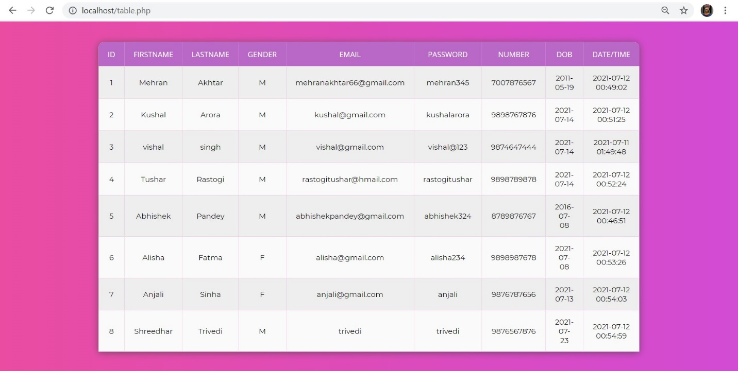7.Database



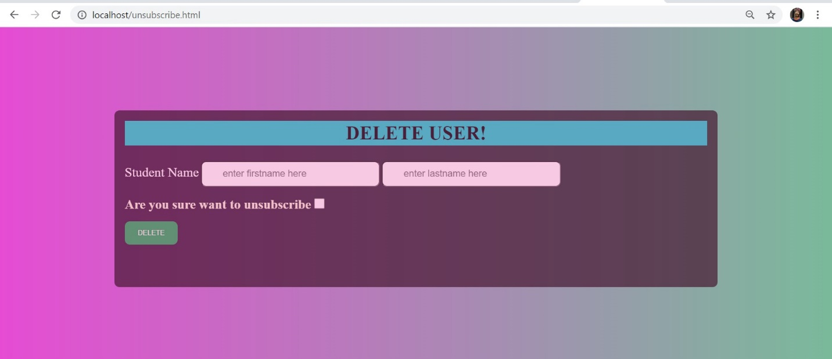8.Unsubscribe User

9.User Unsubscibed

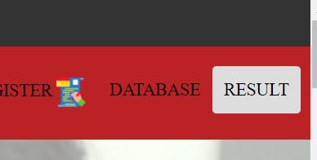 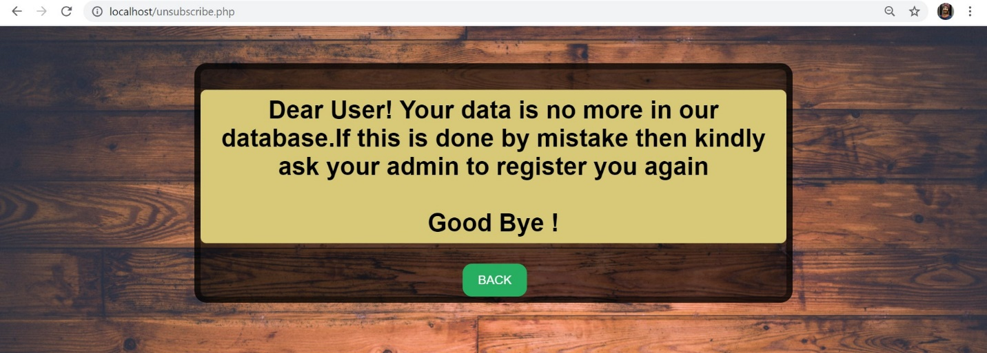

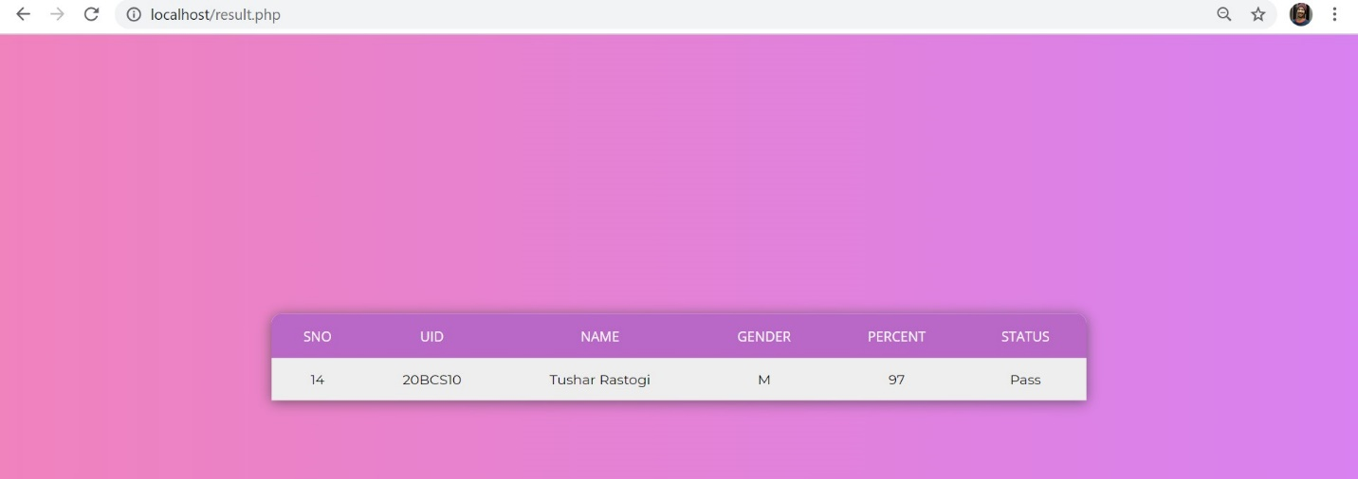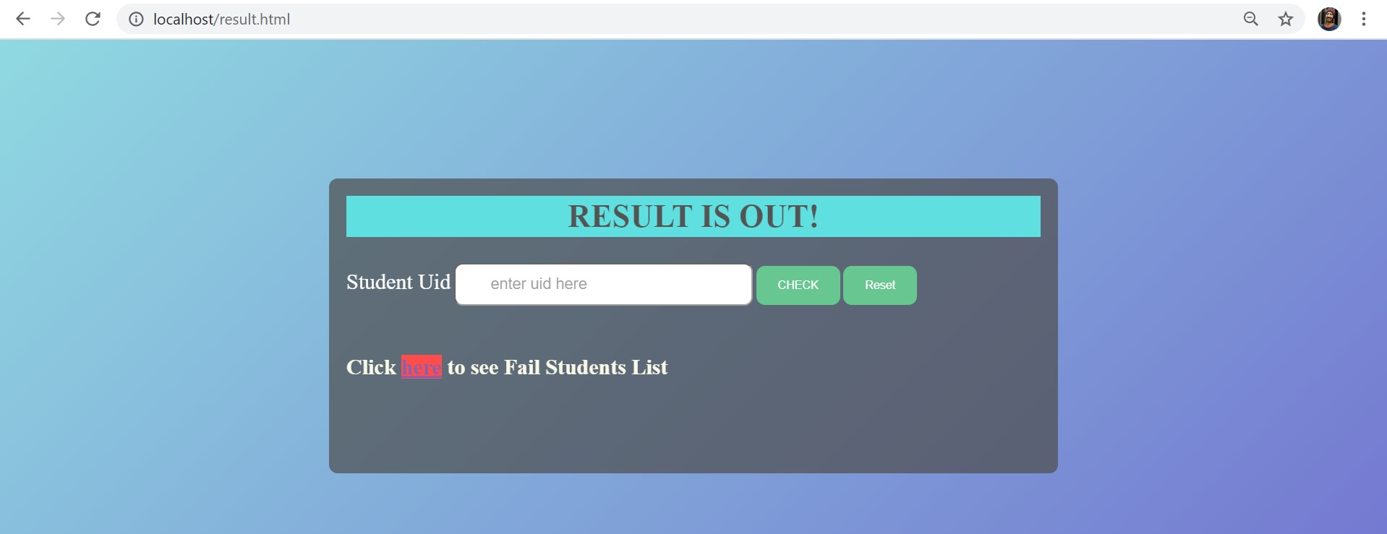10.Result Checking

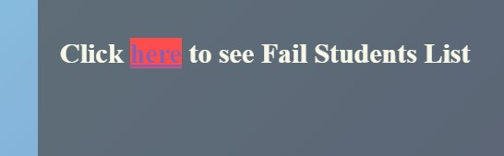

11.Automatic Failure List 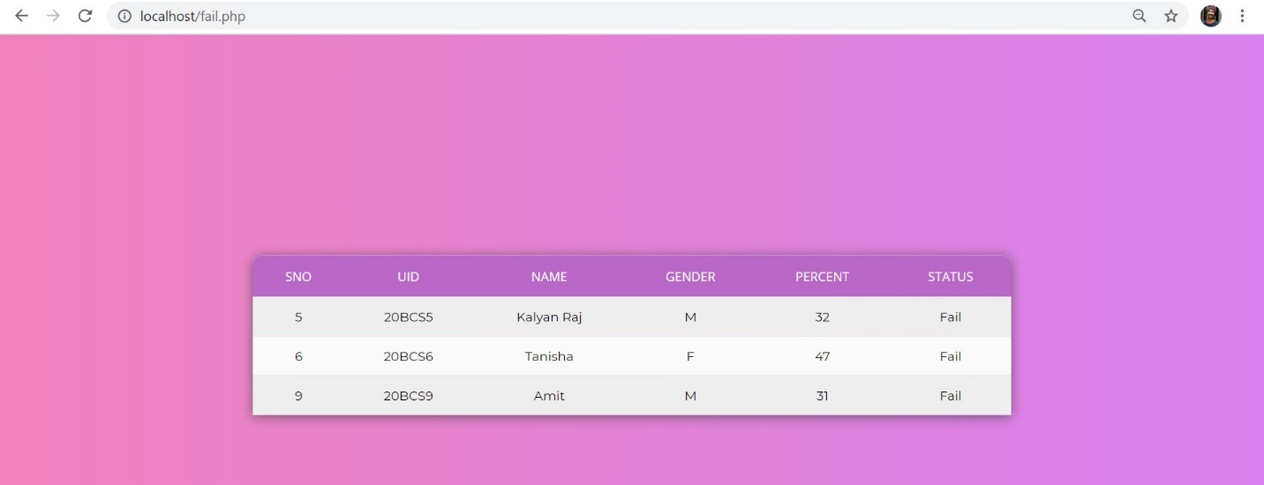

**CONCLUSION AND FUTURE SCOPE**

Last but not the least We as a group would like to say that this project will surely help various school and colleges in a proper data management so that the data manipulation can be easily done.

**Future Scope**

1. Will link our self made Chatbot.
2. Will also give the feature of Ai Assistant that we have already made.
3. A proper Dashboard page for the Admin.
4. A cloud storage for the users.
5. Features of correction of registration details.
6. And some more thing to add...